WEEK 7 — ANALYTICS TESTING & REFINEMENT REPORT
HealthConnect Clinic Experience Lab • AnalystLab Africa • Data Analytics
Final Data Analytics deliverable • Testing, KPI validation, dashboard refinement and validated findings

1. Executive Summary
Week 7 tested the Week 6 Data Analytics outputs rather than repeating the original exploratory analysis. Independent reconciliation against the approved 5,000-row HealthConnect appointment dataset confirmed the core KPI calculations, the principal no-show patterns, and the internal consistency of the source data. The strongest validated signal remains booking lead time, followed by previous no-show history. Reminder status and distance provide supporting descriptive signals, while waiting time shows little separation.

2. Week 6 → Week 7 Transition
Area | Week 6 position | Week 7 result
Primary output | Advanced attendance/no-show decision-support dashboard | Outputs independently reconciled and refined
Testing focus | Strongest analytical signals and KPI framework | KPI, data, segment, filter and visual validation
Main risk | Descriptive findings could be over-interpreted | Association-only wording and limitations documented
Dashboard refinement | Risk-driver and operational visuals | Clearer KPI definitions, ordering, missing-data handling and filter checks
Cross-track evidence | Existing Data Science handoff | Existing handoff used as reference; no new model decision claimed

3. Testing Approach
- Recalculated the main KPIs independently from the original CSV.
- Checked row count, uniqueness, duplicate records, date logic, lead-time consistency and historical-count consistency.
- Recomputed the principal Week 6 findings by lead time, prior no-show history, reminder status, distance and patient status.
- Tested representative dashboard filter scenarios using independent grouped calculations.
- Reviewed visual interpretation for category ordering, missing-data treatment and causal-language risk.
- Retested the refined analytical definitions after the documented changes.

4. KPI Validation
KPI | Validated value | Status | Evidence
Appointment Records | 5,000 | PASS | Independent CSV calculation
No-Show Records | 2,423 | PASS | Independent CSV calculation
Attended Records | 2,314 | PASS | Independent CSV calculation
Cancelled Records | 263 | PASS | Independent CSV calculation
No-Show Rate | 48.46% | PASS | Independent CSV calculation
Attendance Rate | 46.28% | PASS | Independent CSV calculation
Reminder Coverage | 72.68% | PASS | Independent CSV calculation
Repeat No-Show Rate | 55.41% | PASS | Independent CSV calculation
Average Lead Days | 29.64 | PASS | Independent CSV calculation
Average Distance Km | 10.11 | PASS | Independent CSV calculation
The validated headline figures reconcile to the documented project baseline: 48.46% no-show rate, 46.28% attendance rate, 72.68% reminder coverage and approximately 55.41% repeat no-show rate.

5. Data Integrity Tests
Test | Expected | Actual | Result | Interpretation
Row count reconciliation | 5000 | 5000 | PASS | Independent CSV row count matches project baseline.
Unique appointment IDs | 5000 | 5000 | PASS | No duplicate appointment IDs.
Exact duplicate rows | 0 | 0 | PASS | No exact duplicate records.
Missing distance | 90 | 90 | PASS | Missingness retained; no imputation introduced.
Missing waiting time | 60 | 60 | PASS | Missingness retained; no imputation introduced.
Missing reminder channel | 1366 | 1366 | PASS | Structural blanks are expected where no reminder was sent.
Booking date after appointment date | 0 | 0 | PASS | Date sequence is logically consistent.
Lead-day mismatch | 0 | 0 | PASS | Provided lead days agree with date difference.
Previous no-shows > previous appointments | 0 | 0 | PASS | Historical counts are internally consistent.

6. Analytical Validation Results
6.1 Booking lead time
The no-show rate rises monotonically across the observed lead-time groups: 27.81%, 33.55%, 43.21%, 53.82% and 67.69%. The pattern therefore remains valid after independent recalculation.
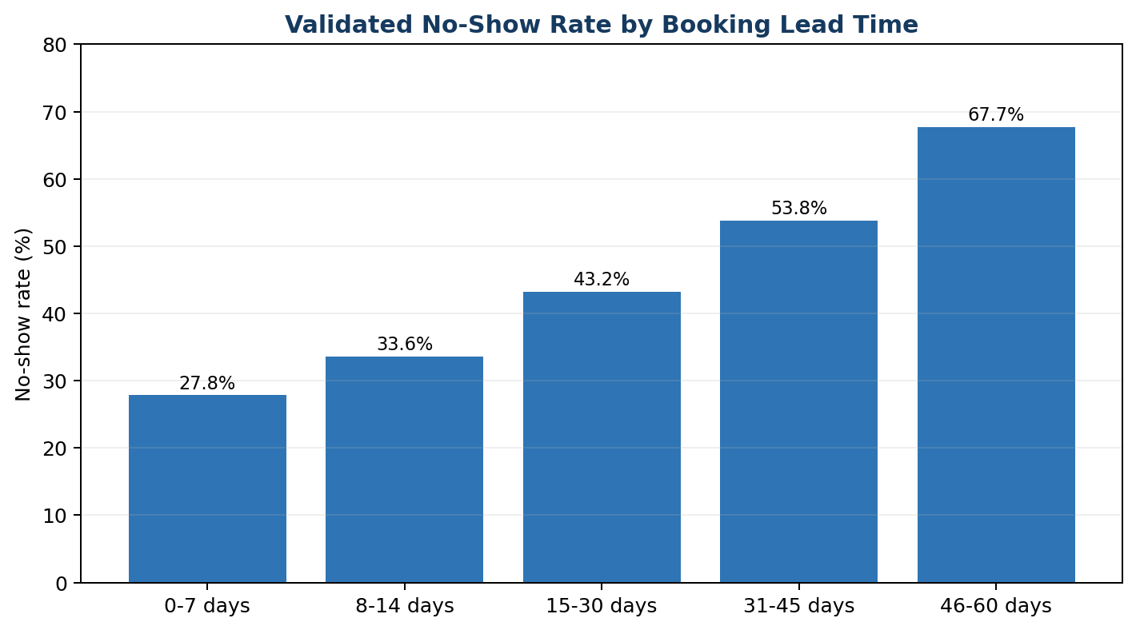
6.2 Previous no-show history
Records with at least one previous no-show have a 55.41% observed no-show rate versus 43.51% among records with no previous no-shows, a 11.90 percentage-point difference.
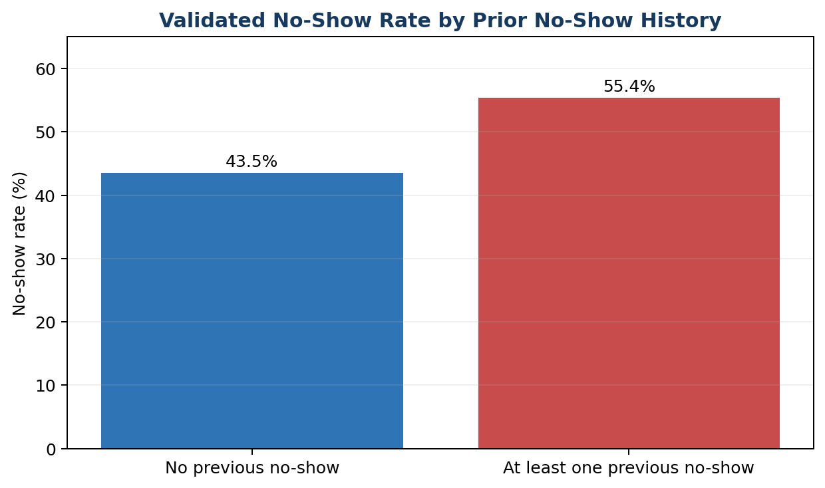
6.3 Reminder status
Appointments with a recorded reminder have a 47.36% observed no-show rate versus 51.39% where no reminder was recorded. This is an association, not evidence that reminders caused the difference.
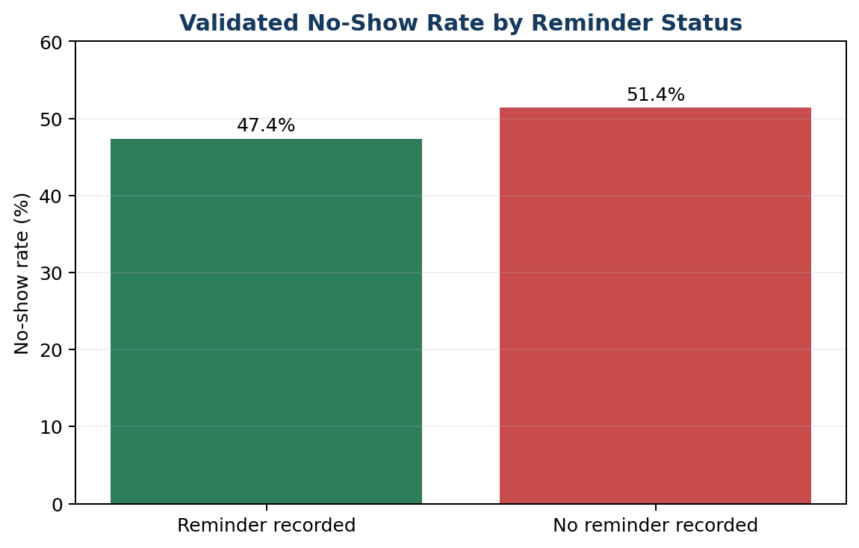
6.4 Distance to clinic
The distance gradient also remains: approximately 46.45% for 0–5 km and 57.76% for 20+ km. The 20+ km group is smaller (393 records), so it should be treated as a supporting rather than standalone conclusion.
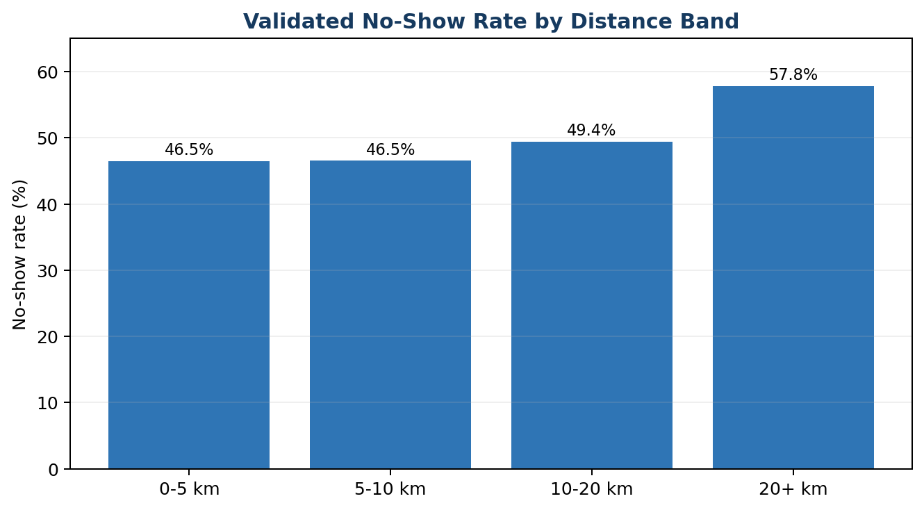
6.5 Patient status
New patients show a 42.98% observed no-show rate versus 48.74% among returning patients. This difference is smaller than the lead-time and prior-no-show effects and should not replace the stronger risk signals.

7. Dashboard Filter & Calculation Testing
Scenario | Expected no-show rate | Actual no-show rate | Result
KPI reconciliation — Repeat No-Show Rate | 55.41% | 55.41% | PASS
KPI reconciliation — Average Lead Days | 2963.86% | 2963.86% | PASS
Filter test — Lead time = 46–60 days | 67.69% | 67.69% | PASS
Filter test — Prior no-show > 0 | 55.41% | 55.41% | PASS
Filter test — Reminder = Yes | 47.36% | 47.36% | PASS
Filter test — Distance = 20+ km | 57.76% | 57.76% | PASS
These tests provide evidence that the main dashboard grouping/filter logic can reproduce the independent analytical results.

8. Refinements Made
Issue | Refinement | Retest
W7-01 | Clarified KPI definitions and retained separate cancelled count; introduced Non-Cancelled No-Show Rate for operational interpretation. | Re-test confirmed reconciled counts/rates.
W7-02 | Documented blanks as structurally linked to reminder_sent = No rather than treating them as ordinary missing data. | Re-test confirmed 1,366 structural blanks.
W7-03 | Retained missing values and used an explicit Unknown category for dashboard banding where needed. | No missing-value inflation in grouped results.
W7-04 | Use Lead Time Sort column and sort Lead Time Group by it. | Visual order verified against 0–7 through 46–60.
W7-05 | Reworded insights as observed associations and added validation language to recommendations. | Final report and dashboard guidance use association-only wording.
W7-06 | Used the existing Week 6 Data Science handoff as the cross-track reference; no new model decision is claimed. | Existing handoff remains the evidence base for feature-alignment discussion.

9. Validated Findings for Decision Support
- Booking lead time is the strongest observed descriptive risk signal. No-show rates rise from 27.81% at 0–7 days to 67.69% at 46–60 days.
- Previous no-show history remains a meaningful observed signal: 55.41% versus 43.51%.
- Reminder recording shows a smaller 3.98 percentage-point difference: 47.36% versus 51.39%.
- Distance is a supporting access-related signal, with 57.76% at 20+ km versus 46.45% at 0–5 km.
- Waiting time remains a weak differentiator and should not be a primary intervention target based on this descriptive evidence.

10. Updated Recommendations
- Review appointments booked substantially in advance and test an additional engagement touchpoint closer to the appointment date.
- Prioritise support workflows for patients with previous no-show history, subject to fairness and operational monitoring.
- Audit the 27.32% of records without a reminder to distinguish intentional non-reminder cases from incomplete recording.
- Investigate distance-related barriers and test whether distance remains informative after adjustment for other appointment characteristics.
- Do not prioritise waiting time as a primary no-show intervention based on the current evidence.

11. Cross-Track Testing Contribution
Week 7 did not create a new Data Science model decision. The existing Week 6 Data Analytics → Data Science handoff was used as the cross-track reference. The validated analytics were checked against the already documented candidate features: booking_lead_days, previous_no_shows, reminder_sent, reminder_channel, distance_to_clinic_km, plus the previously documented engineered variables. This supports continuity without claiming a new meeting, new decision or unverified model change.

12. Limitations & Remaining Analytical Issues
- The dataset is synthetic/anonymised and should not be interpreted as a clinical population estimate.
- Descriptive associations do not establish causation.
- Reminder_channel is structurally blank when no reminder is recorded.
- Distance is missing for 90 records (1.8%); waiting time is missing for 60 records (1.2%).
- The 20+ km distance group is relatively small.
- No meaningful 61+ day lead-time group is present.
- No new Data Science contact or model re-test is claimed for Week 7.

